Java 7 new features

Oct 17, 2015

Recently, I joined AHM classic team. It planned to upgrade to java 8, which brought me the thought of what the new features of java 8 having. I did research on java 8 new features. The best article I found is [‘revisit java 7 new features before welcome java 8’](http://javarevisited.blogspot.co.uk/2014/04/10-jdk-7-features-to-revisit-before-you.html?m=1). As far as I know, most of java developers today’s stop at the features of java 6 since the various frameworks are available now a day able to replace the features in jdk. However, I still believe it is worth to learning the new features jdk 7.

Jdk 7 new features:

1. Type interface

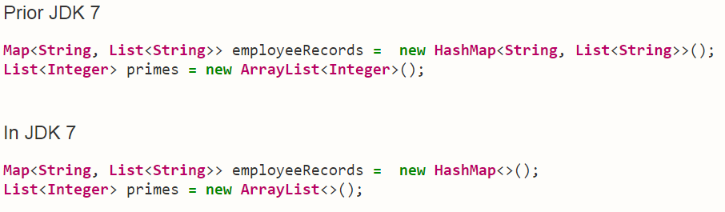

1. Case string

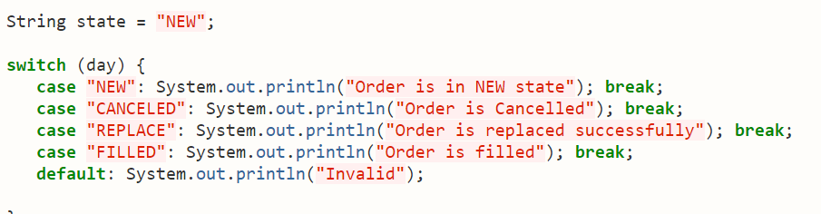

1. Auto resource management
2. Fork join framework
3. Underscore on numeric literal
4. Multiple exception catch in one catch block
5. Binary literal
6. Java NIO 2.0
7. G1 garbage collector
8. Precise re-throw exception